**Small Business Network Design with Secure E-Commerce Server**

**18CSS202J- Computer Communication Project Report**

### *Submitted by*

**Cathy Anand [RA2011026010216]**

**G Veenasree [RA2011026010221]**

**Harshitha Kambham [RA2011026010235]**

*Submitted to*

**Dr. Vegesna S M Srinivasavarma**

Assistant Professor, Department of Computational Technologies

### *in partial fulfilment for the award of the degree of*

**BACHELOR OF TECHNOLOGY**

In

**COMPUTER SCIENCE ENGINEERING WITH** **SPECIALIZATION IN ARTIFICIAL INTELLIGENCE AND MACHINE LEARING**



SCHOOL OF COMPUTING

DEPARTMENT OF COMPUTATIONAL INTELLIGENCE

COLLEGE OF ENGINEERING AND TECHNOLOGY

SRM INSTITUTE OF SCIENCE AND TECHNOLOGY

KATTANKULATHUR- 603 203

**JUNE 2022**

**ABSTRACT**

This project report contains the configuration of static NAT and the use of ACL. In an Ecommerce website there may be many security issues faced while connecting to a server. So, in order to make sure that only certain users are allowed to access the server, we are using this kind of configuration.

This project aims to show that ***[4]***:

1. IP addresses that have been used before are being reused.
2. Increasing the security of private networks by separating internal and external addressing.
3. Using fewer public (external) IP addresses to connect a large number of hosts to the global Internet, hence conserving IP address space ***[5]***.
4. Static NAT is implemented to connect the user to the server.

Thus, security of private networks has been increased using NAT

**OBJECTIVE OF THE PROJECT**

A network has to be designed for a small business organization which has 100 users. The organization hosts an e-commerce application on a server which is accessible to internet users using https and with a public IP address.

**INTRODUCTION**

Learning the implementation of NAT in a small organization to build the security of the customers while accessing the Internet. Through NAT, the private IP addresses of the users are hidden outside the network.

The way that this is implemented is that the configuration of static NAT helps private network users to access the internet by the change from a pool of public addresses in order to access a protected server ***[2]***.

On top of that, we make sure that the server is also kept safe.

**MODULES OF THE PROJECT**

This project is split into two modules - NAT Inside and NAT outside.

**MODULE DESCRIPTIONS**

1. NAT Inside:

This module contains the e-commerce server in order to protect its IP Address from unknown users.

We are using NAT configuration and ACL in order to accomplish this as the ACL will be able to filter out users from the unknown networks while only the networks or particular users present on the list will be able to access it ***[1]***.

1. NAT Outside:

This module consists of the 100 users that are allowed to use the server that is contained inside the NAT configuration.

They are allowed to access the server inside the NAT configuration only if the network is present in a certain access list that works with the NAT ***[3]***.

The access list then filters any unknown networks thus ensuring the safety of the e-commerce server.

**SCREENSHOTS**

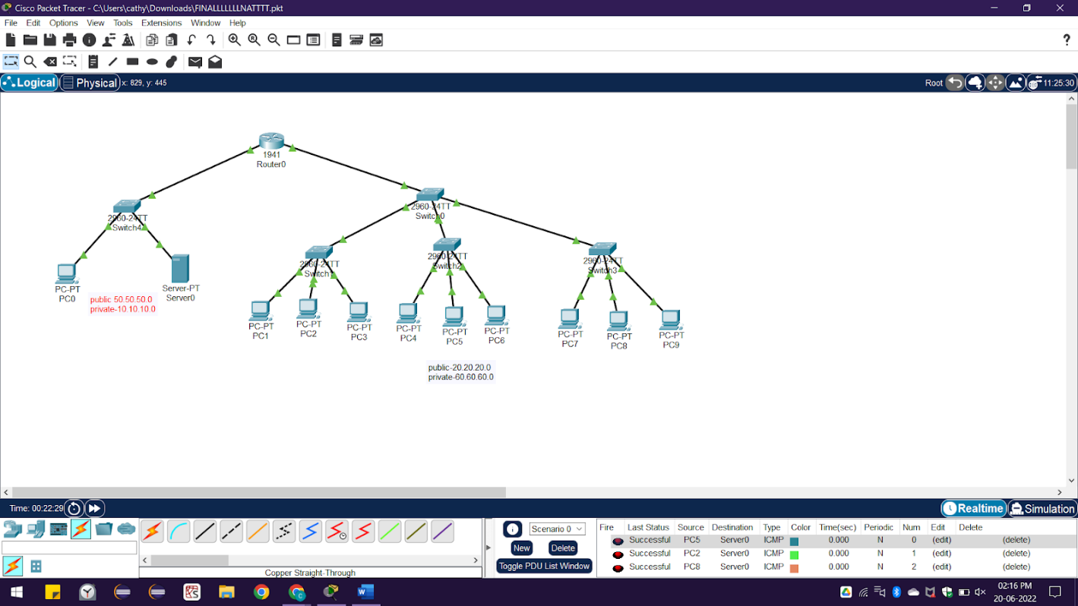

Figure 1. Small scale network topology of the NAT configuration

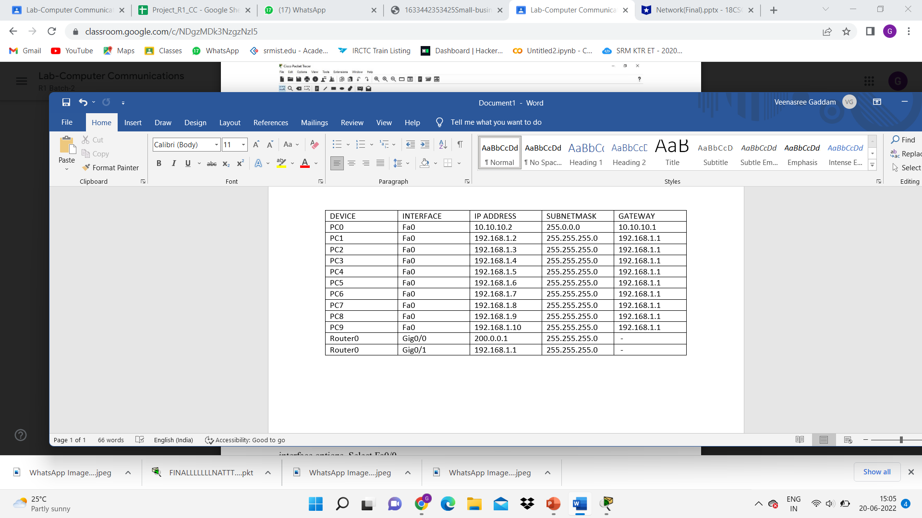

Fig.2. IP Addressing Table for small scale network topology

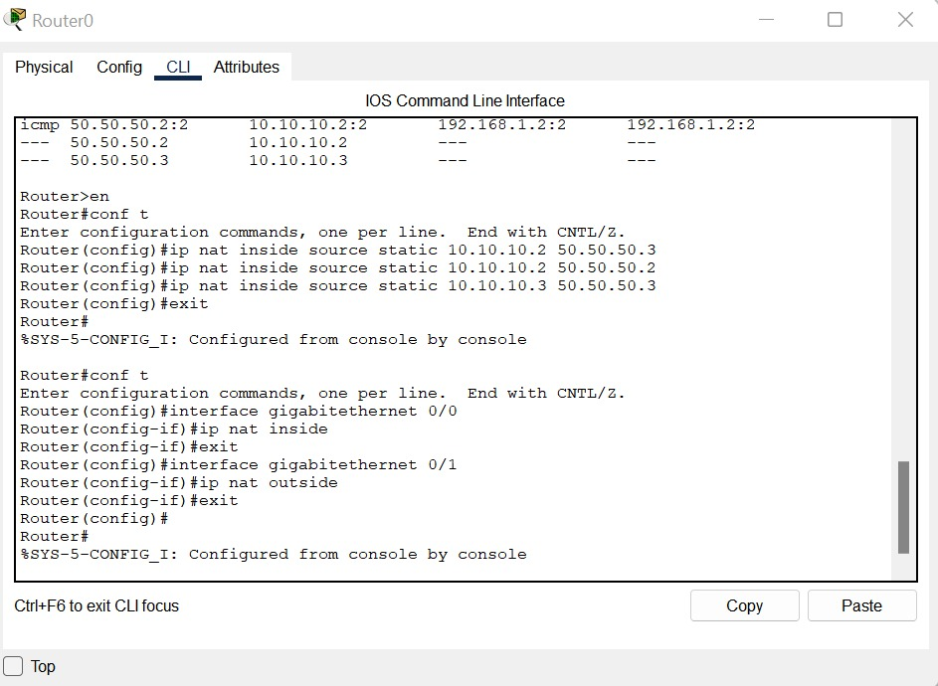

Figure.3. NAT Router Configuration

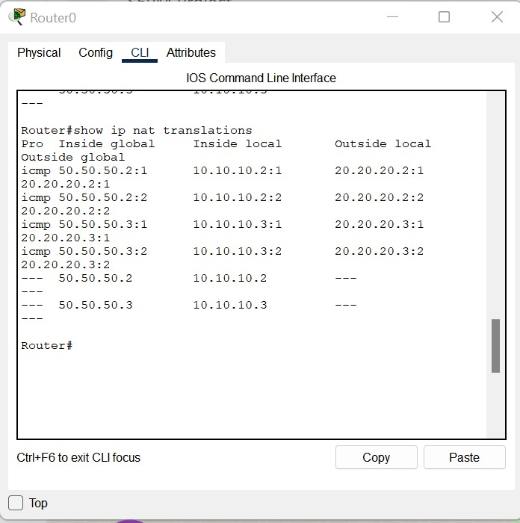

Figure.4. NAT Configuration converting private addresses to public addresses

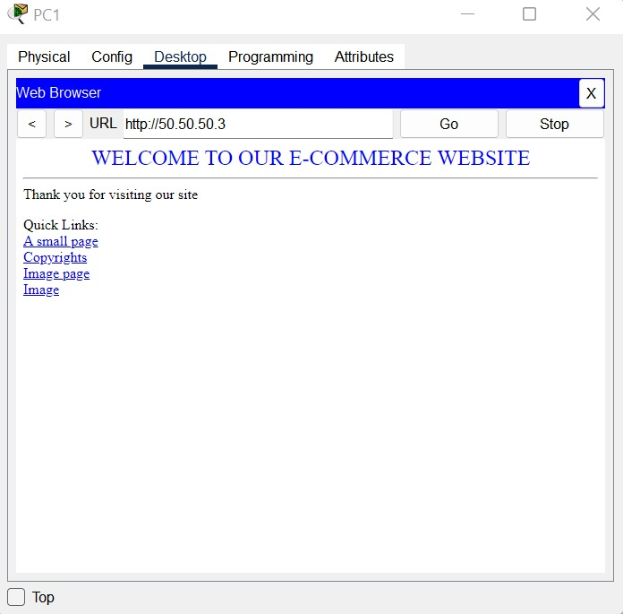

Figure.5. E-Commerce website link

**INFERENCE**

A deep understanding of the concept of NAT.

NAT helped in understanding concepts of privacy and ability to access the internet privately by hiding the IP addresses, even when sending and receiving traffic.

**REFERENCES**

*[1] Sysnettech Solutions - How to configure Static NAT in Cisco Packet Tracer*

<https://www.sysnettechsolutions.com/en/configure-static-nat-in-cisco-packet-trace/>

*[2] Juniper Networks - Network Address Translation User Guide*

<https://www.juniper.net/documentation/us/en/software/junos/nat/topics/topic-map/security-nat-static.html>

*[3] Section - Implementing Network Address Translation (NAT) on a Cisco Router*

<https://www.section.io/engineering-education/implementing-network-address-translation/#network-address-translation>

*[4] Network Node Manager i Software 10.30 - What are the Benefits of NAT?*

<https://docs.microfocus.com/NNMi/10.30/Content/Administer/NNMi_Deployment/Advanced_Configurations/What_are_the_Benefits_of.htm>

*[5] Avast - Public vs. Public IP Addresses: What's the Difference?*

<https://www.avast.com/c-ip-address-public-vs-private>